

**RANI CHENNAMMA UNIVERSITY, BELAGAVI**

**A Project Report**

**On**

**“Inventory Analysis”**

# A PROJECT REPORT SUBMITTED IN PARTIAL FULFILMENT OF

# THE REQUIREMENTS OF BCA COLLEGE, NIDASOSHI.

# Submitted by

**Mr. Fariyaz M Patil(U15CK21S0012)**

**Ms. Vidya V Patil(U15CK21S00135)**

# Under the Guidance of

**Prof. Shilpa K Patil**

# 

# S.N.J.P.S.N.M.S. Trust’s

# BACHELOR OF COMPUTER APPLICATION SCIENCE

# AND COMMERCE DEGREE COLLEGE

# NIDASOSHI.

# 2023-2024



**RANI CHENNAMMA UNIVERSITY, BELAGAVI.**



**S.N.J.P.S.N.M.S TRUST’S**

**BACHELOR OF COMPUTER APPLICATION COLLEGE**

**NIDASOSHI.**

**Certificate**

This is to certify that

**Mr. Fariyaz M Patil(U15CK21S0012)**

**Ms. Vidya V Patil (U15CK21S00135)**

**Has satisfactorily completed the project work entitled**

**“Inventory Analysis”**

**For the partial fulfillment of the requirements of BCA College,**

**Nidasoshi.**

**Guide Principal Examiner**

**1.**

**2.**

(Prof.Shilpa.K.Patil) (Prof.B.M.Halbhavi)



**ACKNOWLEDGEMENT**

Deciding this project to the Almighty God whose abundant grace and Mercies Enabled its successful completion, I would like to express our profound Gratitude To all the people who had inspired and motivated me to make this project a Success.

The sense of contentment and elation that accompanies the successful completion Of my task would be incomplete without mentioning the people who helped in accomplishment of this project, whose Contest guidance, support and encouragements results in the realization.

I would like to express my gratitude to the Management of S.J.P.N TRUST’S BCA COLLEGE, NIDASOSHI, for providing me with all facilities. I am greatly incepted to our beloved Principal, Prof. B.M.Halbhavi sir for the rendered in enabling me to complete project.

I express my heartfelt thanks to our respected project external guide entire Simdaa Technologies team and internal guide Shilpa K Patil, for their enthusiastic training and timely suggestions.

Last but not the least my sincere gratitude to all the staff members, parents and Friends for their help extended for the completion of my project.

Group Members for the Project:

Mr. Fariyaz M Patil (U15CK21S0012)

Mr. Vidya V Patil (U15CK21S00135)

**Abstract**

Analytics has become the cornerstone of decision-making across industries, revolutionizing how businesses operate and compete in today's dynamic market landscape. At its core, analytics involves the systematic analysis of data to derive meaningful insights, enabling organizations to make informed decisions and drive strategic actions. The significance of analytics for the industry can be understood through several key aspects:

Data-Driven Decision Making: Analytics empowers businesses to move away from traditional, intuition-based decision-making towards data-driven strategies. By leveraging advanced analytical techniques, organizations can extract actionable insights from large volumes of structured and unstructured data, enabling them to make informed decisions with greater precision and confidence.

Optimizing Operations and Processes: Analytics enables organizations to optimize their operations and processes by identifying inefficiencies, bottlenecks, and areas for improvement. Whether it's streamlining supply chain logistics, enhancing production processes, or improving customer service operations, analytics provides valuable insights that drive operational excellence and cost savings.

|  |  |  |
| --- | --- | --- |
| **NO** | **INDEX** | **PAGE NO** |
| 1 | Objective and scope | 1-3 |
| 2 | Existing system  2.1 disadvantages of existing system | 4-5 |
| 3 | Proposed system  3.1 advantages of proposed system | 6-8 |
| 4 | Hardware requirement and Software requirements | 9-10 |
| 5 | Methodology Adopted | 11-15 |
| 6 | High level design | 16-17 |
| 7 | Detailed design  7.1 data structure | 18-27 |
| 8 | Implementation | 28-31 |
| 9 | Testing  9.1 methodology for testing  9.2 test reports | 32-36 |
| 10 | Conclusion | 37-38 |
| 11 | Future enhancement | 39-40 |
| 12 | Bibilography | 41-42 |

**Objective & Scope**

**Objective:**

Simdaa technologies prominent and niche player in the advanced analytics and data science domain. Very passionate about building a data-driven culture for their clients by bringing in expertise to solve the challenges at any juncture of Analytics path. We are One Stop Shop for all your Analytics needs. Engaged in providing a high-quality Advance Analytics Solutions while reducing total cost of ownership.

The solution is built in such a way, that it can give much more flexibility in terms of branding, look and feel as well as visual representation of data. On the other hand, the design provides the elasticity so that it can be stretch to accommodate different sets of KPIs and parameters impacting the performance of the respective KPIs.

The very important aspect of this approach is, it's agility and quicker turnaround time. This design gives an additional edge so that it can be implemented in shortest period of time.

This project is to develop an analytical dashboard to perform **Inventory Analysis** for ABBOTT

* **About Client Abbott:**
* Established in 1910, Abbott in India is one of the country’s oldest and most admired healthcare companies. We provide consumers with a diverse range of diagnostics solutions, medical devices, nutritional products and established pharmaceuticals that span the continuum of care.

**Scope:**

Scope of this project is as described below;

* 1. Design & Develop suitable Data Mart is SQL Server
  2. Upload the data into Final Data Mart
  3. Extract & Load Data into Power BI
  4. Define the Data Model in Power BI Suitable for the requirement
  5. Design wireframes suitable for performing the analysis if the data as per the business requirement
  6. Develop Dashboards based on the wireframe
  7. Testing of Data & Dashboards against source
  8. Publishing the Dashboards and give access to the user as per requirements

**Existing System**

**Existing System:**

As of now the existing system is completely manual. The MIS executives creates the report by downloading the dump from source SAP ECC and SAP APO application in excel and create the charts manually.

Below are the highlights of existing system

* 1. All transaction data is captured in SAP ECC ERP system.
  2. The Inventory data is captured in SAP APO System
  3. The data from both the system is extracted into Excel Files
  4. The reports are built in excel
  5. There is no enterprise tool for preparing the analytical tools
  6. The MIS Reports are generated manually by individuals

**Dis-advantages of existing system**

* 1. Entire process is manual and hence error-prone
  2. Different user creates their own reports and hence no single version of truth is maintained
  3. Entire process is time consuming and has dependency on people to generate MIS

**Proposed System**

**Proposed System:**

Considering the challenging requirements for getting more insights quickly developing the subject specific data marts and Power BI Analytics and interactive dashboard is proposed.

Following are the advantages of the proposed new system

1. **Real-time Decision Making:** Analytical dashboards provide up-to-date insights into key performance indicators (KPIs), allowing decision-makers to access relevant information in real-time. This enables swift decision-making based on the latest data, empowering organizations to respond promptly to changing market conditions, customer needs, or operational issues.
2. **Centralized Data Visualization:** Dashboards consolidate data from multiple sources into a single, visually appealing interface. This centralized view allows users to quickly grasp trends, patterns, and outliers, without the need to sift through extensive spreadsheets or reports. By presenting data in a visually intuitive manner, dashboards enhance comprehension and facilitate more informed decision-making.
3. **Customization and Personalization:** Analytical dashboards can be customized to meet the specific needs and preferences of different user groups within an organization. Users can configure dashboards to display the metrics, charts, and visualizations most relevant to their roles and responsibilities. This level of customization ensures that each user receives the insights they need to perform their job effectively.
4. **Performance Monitoring and Goal Tracking:** Dashboards provide a convenient way to monitor performance against predefined goals and targets. By visualizing KPIs and performance metrics in real-time, organizations can track progress towards strategic objectives and identify areas that require attention or improvement. This proactive approach to performance monitoring enables organizations to course-correct and optimize strategies as needed.
5. **Data-driven Insights for Stakeholders:** Analytical dashboards serve as powerful communication tools for sharing insights with stakeholders across the organization. Whether it's executives, managers, or frontline employees, dashboards facilitate data-driven discussions and align stakeholders around common goals and priorities. By fostering a culture of data-driven decision-making, dashboards help drive organizational alignment and accountability.
6. **Efficient Resource Allocation:** Dashboards provide visibility into resource utilization and allocation, helping organizations optimize their use of time, budget, and manpower. By identifying areas of inefficiency or underutilization, organizations can make data-driven decisions to reallocate resources more effectively, ensuring maximum ROI and productivity.

**Hardware & Software Requirement**

* **Hardware Requirement**
  + **For SQL Server**
    - CPU: 2 Core CPU
    - RAM: 16 GB RAM
    - Hard Disk: 500 GB Free Disk Space
  + **For Developers to develop Dashboard**
    - CPU: Intel i5 or equivalent and above
    - RAM: 8 GB RAM or above
    - Hard Disk: Minimum 250 GB Free Space out of which 100 GB on C drive.
    - Internet Connectivity: At least 10 GBS broadband Internet connectivity on all Computers.
* **Software Requirement**
  + SQL Server Standard Edition
  + Power BI Subscription
  + MS Office (Excel, Word & Power Point)

**Methodology Adopted**

**Methodology Adopted:**

To fulfil requirements for analytics, waterfall methodology is not very effective mainly because waterfall model do not encourage end user / customer involvement thought the project life cycle. The customer gets engaged at UAT stage only.

Agile methodology is an iterative approach to software development that emphasizes flexibility, collaboration, and continuous improvement. It emerged as a response to the limitations of traditional, linear development methods like the Waterfall model. Here's a brief overview of Agile methodology:

1. **Iterative Development:** Agile breaks down the development process into small increments called iterations or sprints, typically lasting 1-4 weeks. Each iteration results in a potentially shippable product increment, allowing for early and continuous delivery of valuable software.
2. **Collaborative Approach:** Agile promotes collaboration among cross-functional teams, including developers, designers, testers, and stakeholders. Teams work closely together throughout the project, fostering communication, feedback, and knowledge sharing.
3. **Customer Involvement:** Agile prioritizes customer satisfaction by involving customers or stakeholders in the development process. Customer feedback is solicited regularly, allowing for adjustments and refinements to the product based on changing requirements or priorities.
4. **Adaptive Planning:** Unlike rigid, upfront planning in traditional methods, Agile embraces adaptive planning. Requirements and solutions evolve through the collaborative effort of self-organizing teams, responding to feedback and insights gained during development.
5. **Continuous Improvement:** Agile teams regularly reflect on their processes and outcomes, seeking opportunities for improvement. This emphasis on continuous learning and adaptation fosters a culture of innovation and excellence within the team.
6. **Emphasis on Individuals and Interactions:** Agile values individuals and interactions over processes and tools. While processes and tools are important, Agile recognizes that effective communication and collaboration among team members are paramount to project success.
7. **Embracing Change:** Agile embraces change as a natural part of the development process. Requirements, priorities, and technology evolve over time, and Agile teams are equipped to respond to change quickly and effectively, maximizing the value delivered to customers.

Overall, Agile methodology enables teams to deliver high-quality software products efficiently, adapt to changing requirements, and foster a culture of collaboration and continuous improvement.

Below are the several advantages using Agile methodology over waterfall model.

**Agile Approach:**

* Agile is a set of methods and practices that focuses on iterative development.
* Clients have visibility of each phase of the project.
* The agile manifesto and 12 principles help an organization become agile.
* It emphasizes collaboration, flexibility, continuous improvement and high-quality results.

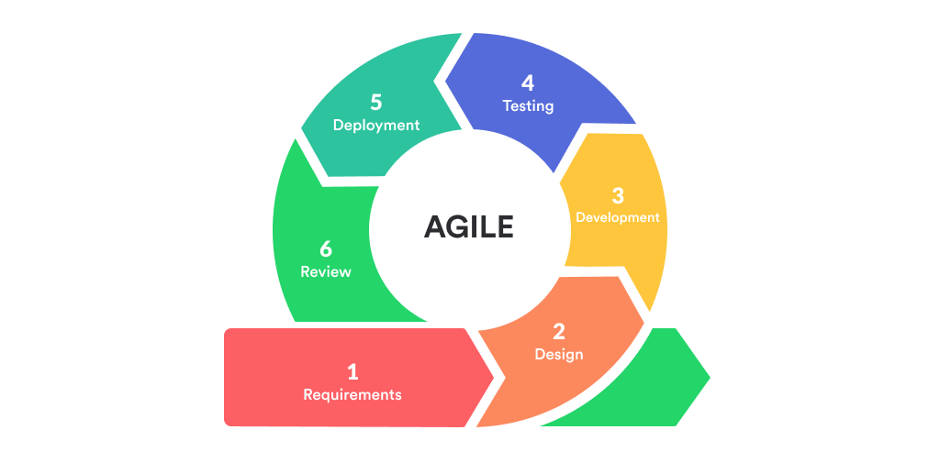

Below are the iterations Planned

Iteration **1: Getting Ready**

1. **Understand requirement:** In this phase we understand how the budgeting works in companies. We also understand its significance and importance of monitoring the company performance with respect to budget.
2. **Understand the source Data:** Hear we analysed the source data and prepared the ER Diagram, Logical Data Model & Physical Data Model.
3. **High Level Design**: Based on the inputs we have designed the high-level design explaining how data will flow into dashboards.
4. **Preparing Database:** Based on the physical data model, staging database along with required tables has been created.
5. **Uploading Data:** The data has been uploaded to databaseusing the import data utility of SQL Server.
6. **Processing Data:** The normalization and ID creation is performed in Staging database
7. **Preparing Data Mart:** Moving the data from staging area to Data mart.

**Iteration 2: Dashboard Development**

1. **Wireframes:** Wireframes are nothing but a raw sketch of proposed dashboard layout. In the wireframes the filters and charts are placed so that user will get an idea about how the final dashboard will look like. Wireframes are inputs for the developers as well so that developers can develop the dashboards as per the wireframes.
2. **Preparing Power BI:** We created a connection from Power BI to SQL Server DataMart Database. After that created data model in Power BI. In this phase, we have created additional calculated column as per requirements.
3. **Developer the Dashboards:** After getting data into **Power BI** the dashboards are developed as per the wireframe. This is a base Version**.**

**Iteration 2: Dashboard Enhancement**

In this iteration the dashboard which is developed earlier will be enhanced with more specific functionalities as per the business requirements. Here the charts and KPI can be changed with new chart types as well as with new measure.

1. **Wireframes:** Wireframes are nothing but a raw sketch of proposed dashboard layout. In the wireframes the filters and charts are placed so that user will get an idea about how the final dashboard will look like. Wireframes are inputs for the developers as well so that developers can develop the dashboards as per the wireframes.
2. **Preparing Power BI:** We created a connection from Power BI to SQL Server DataMart Database. After that created data model in Power BI. In this phase, we have created additional calculated column as per requirements.
3. **Developer the Dashboards:** After getting data into Power BI **the** dashboards are developed as per the wireframe. This is a base Version**.**

**High Level Design**

**Below diagram represent the high-level flow of data movement.**

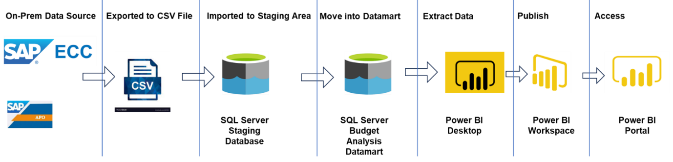

**Step 1:** Transaction data is captured on ongoing basis in SAP ECC ERP Application. The Inventory data is maintained in SAP APO Application. The relevant data is exported into a flat file or excel file.

**Step 2:** The data in flat file is analysed thoroughly. And after analysing the data ER Diagram, Logical Data Model and physical data model is prepared.

**Step 3:** Staging database is created in SQL Server. The tables are created in staging database as per physical data model. The Primary Keys are generated in Staging tables with use of identity property while defining the Primary Key column in Staging Database.

**Step 4:** Data Mart database is created in SQL Server. The normalized data is uploaded into Data Mart Database.

**Step 5:** Connection is created in Power BI to connect and fetch data from SQL Server DataMart Database. Data model in Power BI Desktop is created. Created new calculated column as per requirement in Power BI.

After data model is created in Power BI, the dashboards are developed as per the wireframe defined.

**Step 6:** Once the Dashboards are tested and verified, it will be published on the Power BI portal.

**Step 7:** Once the dashboards are published on Power BI Portal in respective workspace. It will be accessed by targeted audience as per the access is provide.

**Detailed Design**

Before starting the detailing on design, we have learned more about Data.

**Type Of Data**

**Data can be classified in several types as mentioned below**

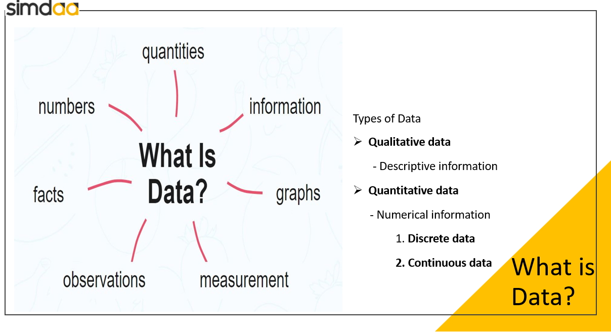

* **Qualitative Data**
* Qualitative data is information that cannot be counted, measured or easily expressed using numbers. It is collected from text, audio and images and shared through data visualization tools, such as word clouds, timelines, graph databases, concept maps and infographics.
* Qualitative data analysis tries to answer questions about what actions people take and what motivates them to take those actions. Collecting and working with this kind of data can be time-consuming, because it requires reflection on the part of the analyst. Someone who works with qualitative data is called a qualitative researcher or qualitative analyst.
* **Quantitative Data**
* Quantitative data is the value of data in the form of counts or numbers where each data set has a unique numerical value. This data is any quantifiable information that researchers can use for mathematical calculations and statistical analysis to make real-life decisions based on these mathematical derivations.

**There is further two sub types Quantitative Data**

1. Discrete Data
2. Continuous Data

**Discrete Data**

Data that can only take certain values is called discrete data or discrete values. This is data that can be counted and has a limited number of values. It usually comes in the form of whole numbers or integers. These values must fit into certain categories and can’t be broken into smaller parts.

Discrete data examples include the following:

The size of your department’s workforce.

How many new clients you brought on board in the previous quarter?

How many items are currently kept in stock?

However, your daily total is a distinct, single amount. The relationship between the number of push-ups you can do each day and your fitness level is yet unknown. The more data you collect over time, the more conclusions you can draw.

**Continuous Data**

Continuous data are those that can be measured. It is conceivable for this data to take on an unlimited number of different values because its values are not fixed. There are smaller, individual components that make up these metrics as well.

*Continuous data examples would include the following:*

An individual’s stature or weight.

The temperature daily in your city.

How much time is required to finish an activity or project.

The correctness of continuous data is everything. These data sets frequently contain variables with decimal points, with the rightmost number being as long as possible.

This level of information is required, for example, by scientists, physicians, and manufacturers*.*

For detailing the design, we used 4 different methods as described below;

**Entity Relationship Diagram:**

An Entity-Relationship Diagram (ERD) is a visual representation used to design databases. It illustrates the entities within a system or organization, their attributes, and the relationships between them. Entities represent real-world objects or concepts, such as customers, products, or orders. Attributes are properties or characteristics of entities, while relationships show how entities are connected or interact with each other. ERDs help to visualize the structure of a database and understand how data is organized and related, which is essential for database design and development.

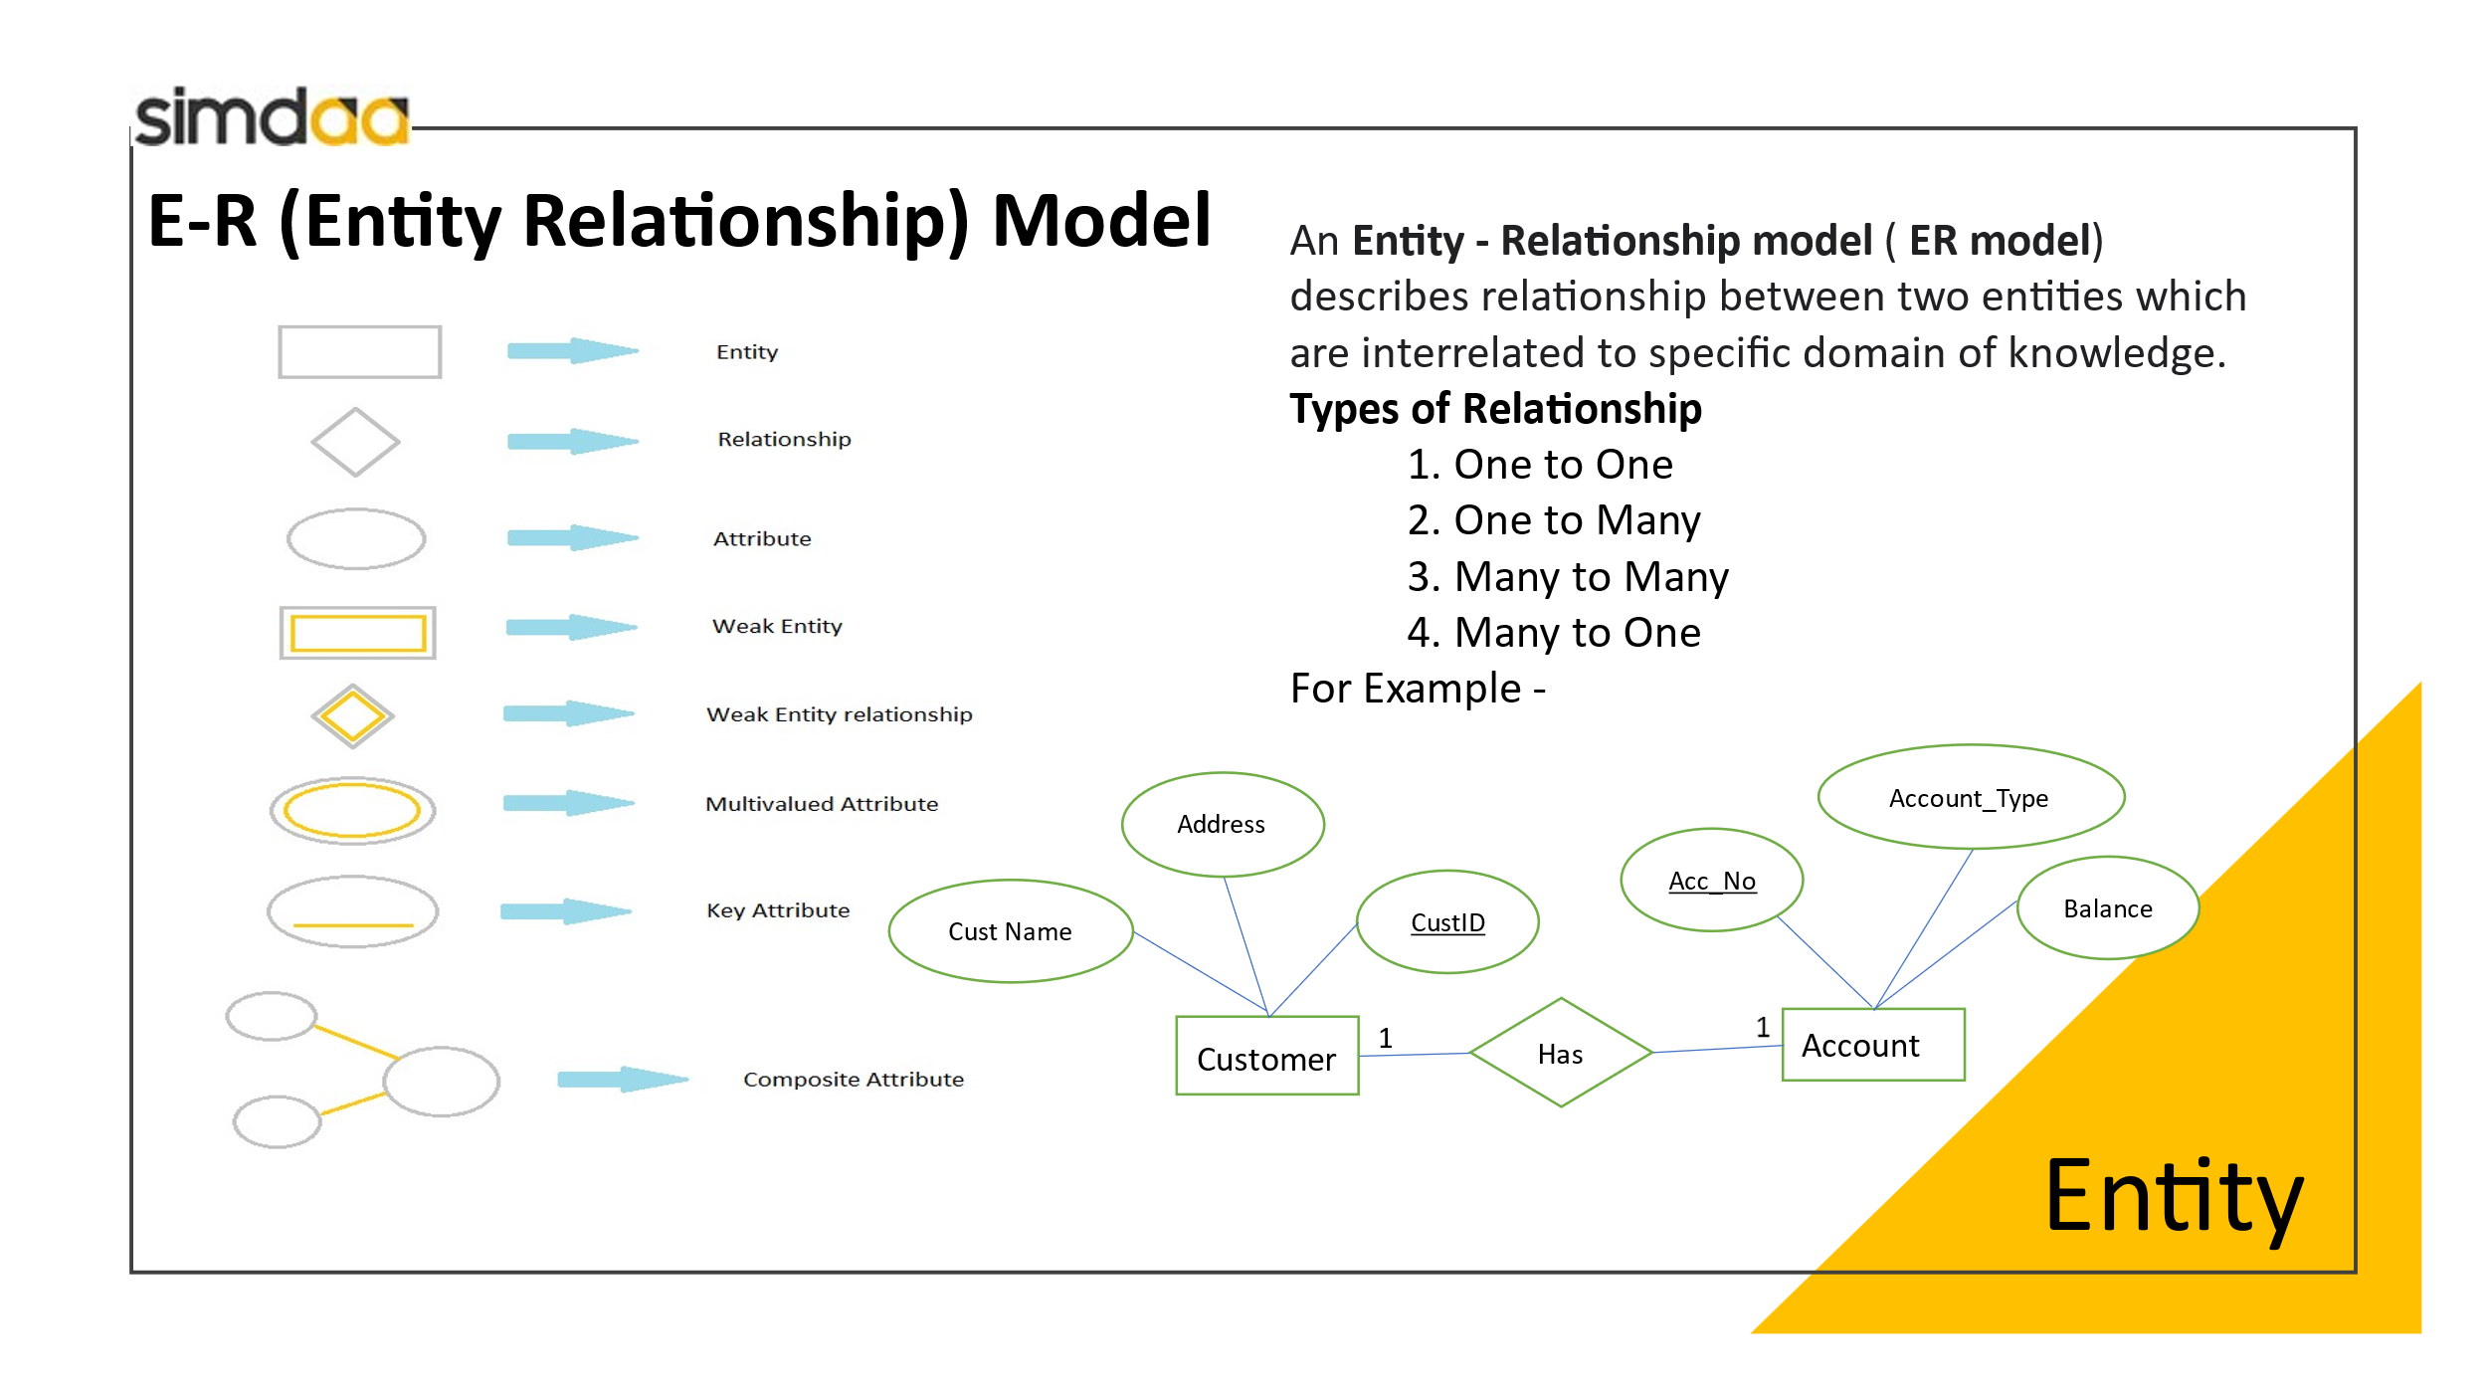

Following is ER Diagram for our Project on Inventory analysis Dashboard

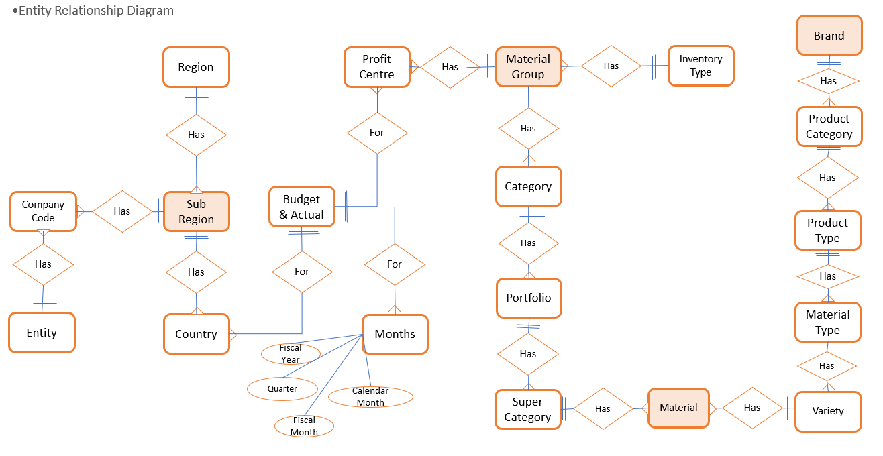

**Logical Data Model**:

A logical data model is a representation of the structure of a database independent of a specific database management system (DBMS) or physical implementation. It focuses on the logical relationships between data elements rather than on how the data will be stored or accessed.

In a logical data model:

1. **Entities:** These are the main objects or concepts about which data is stored. Entities have attributes that describe their properties.
2. **Attributes:** Attributes are characteristics or properties of entities. They describe the data stored within each entity.
3. **Relationships:** Relationships define how entities are connected or associated with each other. They illustrate how data from different entities relate to one another.

Logical data models are often represented using diagrams such as Entity-Relationship Diagrams (ERDs) or Unified Modelling Language (UML) diagrams. They serve as a blueprint for database design, providing a clear understanding of the structure and organization of data within the system.

Following is the Logical Data Model for Inventory Analysis Dashboard database

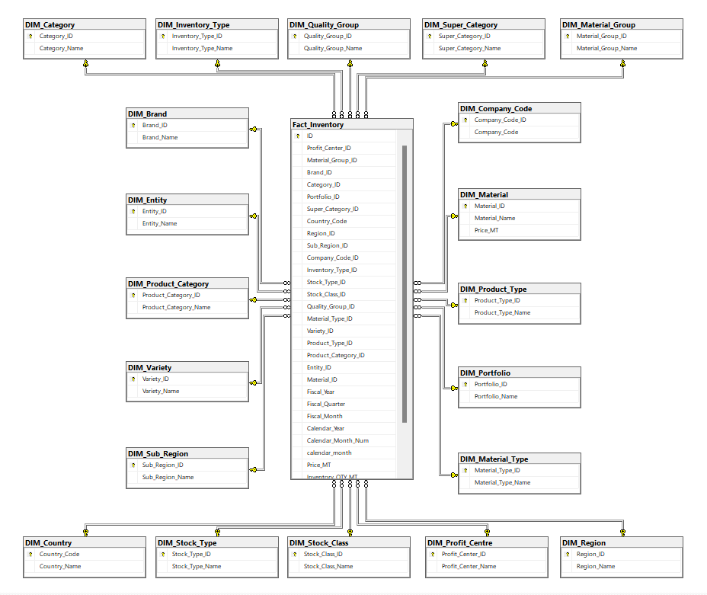

**Physical Data Model**

A physical data model is a detailed representation of how data is stored in a specific database management system (DBMS) or physical storage medium. Unlike logical data models, which focus on the structure and relationships of data independent of any particular technology, physical data models address the specifics of how data will be implemented within a particular DBMS.

Following is the Physical Data Model for Inventory Analysis Dashboard database.

**Key aspects of a physical data model include:**

1. **Data Types and Constraints:** Specifies the data types and constraints (such as not null, unique, or foreign key constraints) for each attribute in the database schema.
2. **Indexes and Keys:** Defines primary keys, foreign keys, and indexes to optimize data retrieval and enforce data integrity.
3. **Storage Parameters:** Specifies parameters such as block size, tablespaces, partitions, and filegroups, which determine how data is physically stored on disk for optimal performance. In our case this is not applicable as sample data size is not very big.
4. **Normalization and Denormalization:** Determines the degree of normalization or denormalization needed for efficient data storage and retrieval, balancing between minimizing redundancy and optimizing query performance.
5. **Partitioning and Clustering:** Defines strategies for partitioning large tables or clustering related data together to enhance performance and manageability.

In our case this is not applicable as sample data size is not very big

Physical data models are typically created after the logical data model has been designed, as they are closely tied to the specific implementation details of the chosen DBMS. They provide the necessary details for database administrators and developers to implement the database schema efficiently and effectively.

**Wireframes:**

Wireframes are basic visual guides used in the early stages of designing a webpage or app. They outline the structure and layout without focusing on design details like colors or images. Think of them as blueprints that show where elements like headers, buttons, and text will be placed.

1. **Hierarchy and Layout:** Wireframes establish the hierarchy of content and layout of elements on a page or screen. They show where various components such as navigation menus, buttons, forms, and content blocks will be placed.
2. **Functionality:** Wireframes illustrate the functionality and interactions of different elements, including how users will navigate through the interface, access information, and perform actions.
3. **Simplicity:** Wireframes emphasize simplicity and clarity, using basic shapes, lines, and text to represent interface elements. They avoid distractions such as colours or detailed graphics to focus on the structure and flow of the interface.
4. **Feedback and Iteration:** Wireframes serve as a communication tool between designers, developers, and stakeholders, allowing them to provide feedback and make revisions early in the design process. They facilitate iteration and refinement of the interface before more detailed design work is undertaken.

**Data Structure**

|  |  |  |  |  |
| --- | --- | --- | --- | --- |
| **TABLE_NAME** | **COULUMN_NAME** | **IS_NULLABLE** | **DATA_TYPE** | **MAX LENGTH** |
| Invenotry_Anlysis_final | Fiscal_year | No | nvarckar | 50 |
| Invenotry_Anlysis_final | Fiscal_Quarter | No | nvarchar | 50 |
| Invenotry_Anlysis_final | Fiscal_Month | No | nvarchar | 50 |
| Invenotry_Anlysis_final | Calendar_Year | No | int | NULL |
| Invenotry_Anlysis_final | Calendar_mon_no | No | int | NULL |
| Invenotry_Anlysis_final | Calendar_month | No | nvarchar | 50 |
| Invenotry_Anlysis_final | Material | No | nvarchar | 50 |
| Invenotry_Anlysis_final | Super_category | No | nvarchar | 50 |
| Invenotry_Anlysis_final | Inventory_type | No | nvarchar | 50 |
| Invenotry_Anlysis_final | Variaty | No | nvarchar | 50 |
| Invenotry_Anlysis_final | Material_type | No | nvarchar | 50 |
| Invenotry_Anlysis_final | Product_type | No | nvarchar | 50 |
| Invenotry_Anlysis_final | Product_category | No | nvarchar | 50 |
| Invenotry_Anlysis_final | Brand | No | nvarchar | 50 |
| Invenotry_Anlysis_final | Qulity_group | No | nvarchar | 50 |
| Invenotry_Anlysis_final | Stock_type | No | nvarchar | 50 |
| Invenotry_Anlysis_final | Stock_class | No | nvarchar | 50 |
| Invenotry_Anlysis_final | Profit_center | No | nvarchar | 50 |
| Invenotry_Anlysis_final | Region | No | nvarhcar | 50 |
| Invenotry_Anlysis_final | Sub_region | No | nvarhcar | 50 |
| Invenotry_Anlysis_final | Country | No | nvarhcar | 50 |
| Invenotry_Anlysis_final | Country_code | No | nvarchar | 50 |
| Invenotry_Anlysis_final | Company_code | No | nvarchar | 50 |
| Invenotry_Anlysis_final | Entity | No | nvarchar | 50 |
| Invenotry_Anlysis_final | Price_MT | No | Int | NULL |
| Invenotry_Anlysis_final | Inventory_Quty_mt | No | int | NULL |
| Invenotry_Anlysis_final | Inventory_turnover_ratio | Yes | int | NULL |
| Invenotry_Anlysis_final | Invenotory_days | No | nvarchar | 50 |
| STG_Profit_Center | Profit_center_id | No | bigint | 50 |
| STG_Profit_Center | Profit_center_name | Yes | nvarchar | 150 |
| STG_Material_Group | Material_group_id | No | bigint | NULL |
| STG_Material_Group | Material_group_name | Yes | nvarchar | 150 |
| STG_Brand | Brand_id | No | bigint | NULL |
| STG_Brand | Brand_name | Yes | nvarchar | 150 |
| STG_Category | Category_id | No | bigint | NULL |
| STG_Category | Category_Name | Yes | nvarchar | 150 |
| STG_Portfolio | Profit_id | No | bigint | NULL |
| STG_Portfolio | Portfolio Name | Yes | nvarhcar | 150 |
| STG_Super_Category | Super_category_id | No | bigint | NULL |
| STG_Super_Category | Super_category_name | nvarchar | yes | 150 |
| STG_Country | Country_code | No | varchar | 50 |
| STG_Country | Country_Name | Yes | nvarchar | 150 |
| STG_Region | Region_id | No | bigint | NULL |
| STG_Region | Region_name | Yes | nvarchar | 150 |
| STG_Sub_Region | Sub_Region_id | No | bigint | NULL |
| STG_Sub_Region | Sub_Region_Name | Yes | nvarchar | 150 |
| STG_Company_Code | Company_code_id | No | bigint | NULL |
| STG_Company_Code | Company_code | Yes | nvarhcar | 150 |

**Implementation**

**Implementation**

Implementing Power BI dashboards involves several steps:

1. **Data Preparation:** Gather and prepare the data you want to visualize in your dashboard. This may involve importing data from various sources such as databases, Excel files, or online services, and transforming it into a format suitable for analysis.
2. **Creating Data model in Power BI:** Use Power BI Desktop to create data model. Using Query Editor you can create calculated fields.
3. **Building Dashboards:** Once you have created data model, you can combine onto a canvas to create visualizations such as charts, graphs, tables, and maps by dragging and dropping the measure and dimensions. You can further customize these visualizations to convey the insights you want to highlight them into a dashboard. Dashboards provide a high-level view of your data, allowing users to see key metrics and trends at a glance. Arrange your reports on the dashboard canvas and add additional elements such as text boxes, images, or shapes to provide context or guidance.
4. **Data Refresh:** Set up scheduled data refresh to ensure that your dashboard always displays the latest information. Power BI can automatically refresh your data from its original sources on a regular basis, keeping your dashboard up to date without manual intervention.
5. **Sharing and Collaboration:** Share your Power BI dashboard with others in your organization or external stakeholders. You can publish your dashboard to the Power BI service, where users can view it in a web browser or mobile app. You can also collaborate with others by sharing and collaborating on reports and datasets.
6. **Monitoring and Maintenance:** Monitor the performance of your dashboard and make adjustments as needed. Use usage analytics to understand how users interact with your dashboard and identify areas for improvement. Regularly review and update your dashboard to ensure that it continues to meet the needs of your audience.

Following are the wireframes created for Inventory Analysis Dashboard

**Page 1: Inventory Overview:**

On this page the Inventory value analysis is display by various dimensions as follows

1. Time
2. Group_Id
3. Region
4. Category_Name

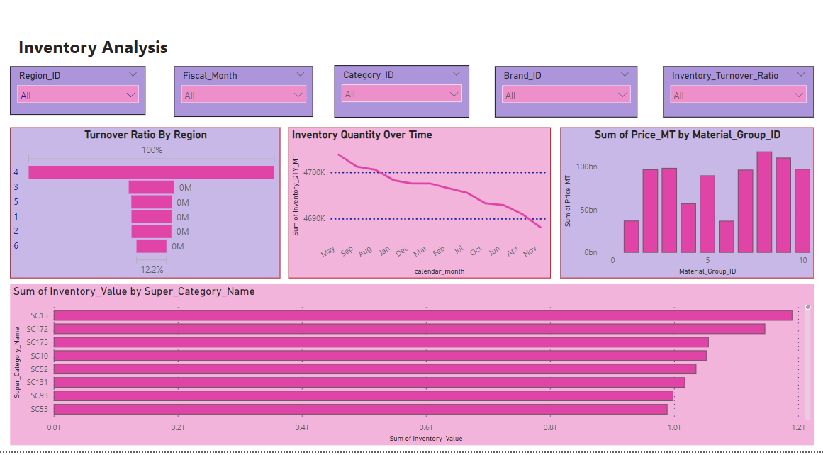

**Page 2: Inventory Ratio Analysis**

On this page the Inventory Ratio analysis is display by various dimensions as follows

1. Profit Centre
2. Region
3. Time
4. Product Category

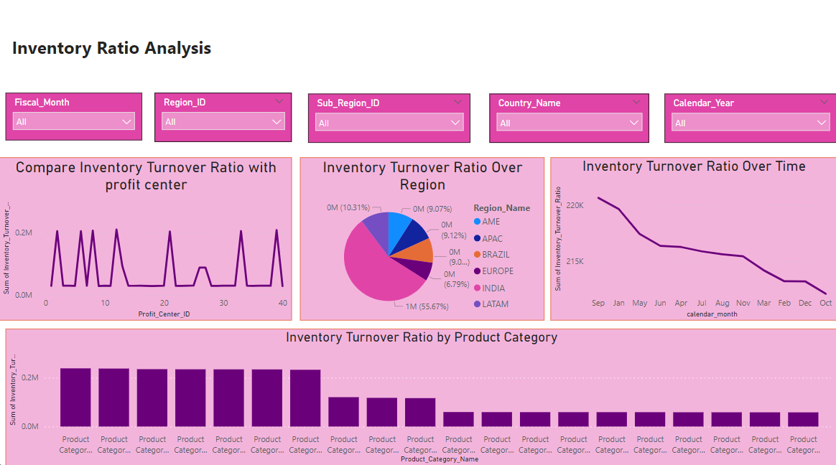

**Page 3 – Inventory Analysis**

This is one more variation of Page 1. On this page Inventory quantity analysis is done by Material Group, Brand, Super Category.

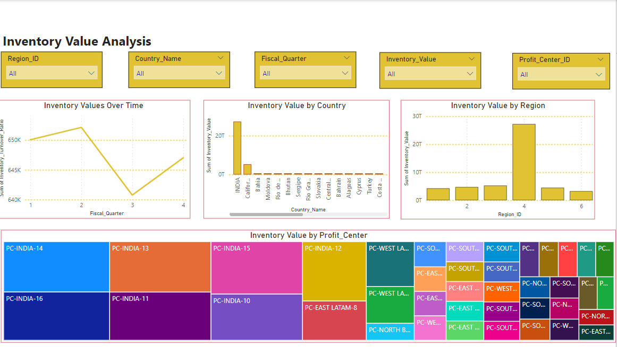

**Testing**

Choosing the best testing methodology for Business Intelligence (BI) and Analytics depends on several factors such as the project scope, requirements, timeline, and resources available. However, some commonly used testing methodologies in BI and Analytics projects include:

1. **Manual Testing:** Manual testing involves human testers executing test cases to verify the correctness and completeness of BI reports, dashboards, and analytical outputs. This approach allows testers to explore the system's functionality, identify user experience issues, and validate data accuracy.
2. **Automated Testing:** Automated testing uses software tools to execute test cases automatically. Automated testing is particularly beneficial for repetitive tasks, regression testing, and large-scale BI implementations. It helps improve testing efficiency, consistency, and coverage while reducing manual effort.
3. **Regression Testing:** Regression testing ensures that changes or enhancements to BI reports, dashboards, or underlying data structures do not introduce new defects or regressions. It involves retesting existing functionalities to verify that they continue to work as expected after modifications.
4. **Performance Testing:** Performance testing assesses the responsiveness, scalability, and reliability of BI systems under various load conditions. It helps identify performance bottlenecks, optimize query performance, and ensure that BI applications can handle concurrent user interactions and large datasets efficiently.
5. **Data Quality Testing**: Data quality testing focuses on validating the accuracy, completeness, consistency, and integrity of data used in BI and Analytics. It involves profiling data, identifying anomalies, resolving data inconsistencies, and ensuring data governance and compliance.
6. **User Acceptance Testing (UAT):** UAT involves end-users validating BI reports, dashboards, and analytical outputs to ensure they meet business requirements and user expectations. UAT helps gather feedback, uncover usability issues, and validate the overall fitness for purpose of BI solutions.
7. **Exploratory Testing:** Exploratory testing involves ad-hoc testing by skilled testers to explore BI applications, uncover defects, and evaluate system behaviour from different perspectives. It complements scripted testing approaches by encouraging creativity, intuition, and real-world simulation.
8. **Agile Testing:** Agile testing aligns with Agile development methodologies such as Scrum or Kanban, emphasizing collaboration, continuous feedback, and iterative development. Agile testing enables early and frequent testing, rapid adaptation to changing requirements, and close collaboration between developers, testers, and stakeholders.

Ultimately, the best testing methodology for BI and Analytics projects depends on the specific requirements, objectives, and constraints of the project, as well as the organizational culture and preferences regarding testing practices. It's often beneficial to tailor the testing approach to the unique characteristics of each BI initiative to achieve the best outcomes.

For our project we have adopted agile testing methodology. Below are the Test cases followed.

1. Database objects are created as per the documentation.
2. Data uploaded in to database is matching with source file by checking no of records uploaded as well as sum of measures are matching or not.
3. The data in dashboard is matching with database or not.
4. The dashboard is created as per wireframe or not.

**Test Results**

|  |  |  |  |  |
| --- | --- | --- | --- | --- |
| Test Case | | Expected output | Observed output | Result |
| 1 | Staging Database | Staging Database must be created | Staging database STG_Inventory_Analysis is available | OK |
| 2. | Tables are created in staging database as per Physical Data Model. | tables mentioned in documentation needs to be created as the structure mentiond in the document | Following tables are created and their structure is matching with Physical Data Models.  STG_Profit_Centre  STG_Material_Group  STG_Brand  STG_Category  STG_Portfolio  STG_Super_Category  STG_Country  STG_Region  STG_Sub_Region  STG_Company_Code  STG_Inventory_Type  STG_Stock_Type  STG_Stock_Class  STG_Quality_Group  STG_Material_Type  STG_Variety  STG_Product_Type  STG_Product_Category  STG_Entity  STG_Material | OK |
| 3 | Data is populated in Staging database | The number of rows and sum of measures are matching | Following is the output  No of Rows: 4,32,000  Total Inventory QTY MT: 25589014  Total Inventory Value : 22457808615598 | OK |
| 4. | Dashboard is created as per wireframes | The dashboard should be as per the wireframe defined | The dashboard is as per the wireframe and matching the values perfectly. | OK |

**conclusion**

**Conclusion**

The Inventory Analysis Dashboard, developed using SQL Server and Power BI, fully meets the objectives of performing detailed analysis of inventory across various dimensions. This tool provides businesses with valuable insights into their company’s performance by comparing inventory levels. Additionally, the dashboard helps identify areas for improvement to boost performance in weaker areas.

Working on this exciting and challenging project has been a great pleasure. It has been particularly beneficial for me as it introduced me to the technical domain of analytics, which will invariably open new career opportunities. Moreover, this project has enabled me to learn SQL Server and Power BI to the extent that I can now deliver industry-standard analytics applications independently.

**Future enhancements**

**Future enhancements:**

Any analytics application is never final. Business requirements keep changing and hence the analytics application also need enhancements to keep it relevant to the business.

In the inventory analysis application, we have focused primarily on sales data. In the future, we can expand our analysis to include raw material inventory and other inventory-related cost centers to monitor the company's performance more comprehensively.

**References**

**Bibliography**

**For SQL**

SQL: The complete Reference, 3rd edition

by James.R. Groff.

SQL for data analytics

By upom malik

**Microsoft Power BI**

Jack Hyman

**Superchange Excel**

Matt Allington